🍔 GIU Food Truck Ordering System

📌 Project Description

The GIU Food Truck Ordering System is a full-stack web application that allows customers to browse food trucks, view menus, place orders, and track their order status, while enabling food truck owners to manage menus, orders, and availability through a dedicated dashboard.

This project was developed as part of the GIU coursework to demonstrate full-stack development using Node.js, Express, Hogan.js, jQuery, AJAX, and MySQL.

⸻

👤 Team Information
• Project Title: GIU Food Truck Ordering System
• Student Name: Mahmoud Hossam Eldin Ibrahim
• Tutorial Group: T14
• Work Type: Individual Project

⸻

✨ Features

👥 Customer Features
• User registration and login
• Browse available food trucks
• View truck menus
• Add menu items to cart
• Manage cart (increase, decrease, remove items)
• Place orders
• Track order status (Pending, Preparing, Ready, Completed, Cancelled)
• View order history
• Logout functionality

⸻

🚚 Truck Owner Features
• Owner login
• Owner dashboard with statistics
• Toggle truck availability (Open / Closed)
• Add new menu items
• Edit existing menu items
• Delete menu items
• View incoming orders
• Update order status
• View completed orders
• Logout functionality

⸻

🛠 Technology Stack

Frontend
• HTML (Hogan.js templates .hjs)
• CSS (Custom styling + Bootstrap)
• JavaScript
• jQuery
• AJAX

Backend
• Node.js
• Express.js
• Hogan.js (View Engine)

Database
• MySQL

⸻

🗂 Entity Relationship Diagram (ERD)

Tables Used

Users:

Column Type
id INT (PK)
name VARCHAR
email VARCHAR
password VARCHAR
role ENUM (customer, owner)
birthDate DATE
createdAt TIMESTAMP

Trucks:

Column Type
id INT (PK)
name VARCHAR
logo VARCHAR
status ENUM (open, closed)
ownerId INT (FK → users.id)

Menu_items:

Column Type
id INT (PK)
truckId INT (FK → trucks.id)
name VARCHAR
category VARCHAR
description TEXT
price DECIMAL
status ENUM (available, unavailable)

Orders:

Column Type
id INT (PK)
userId INT (FK → users.id)
truckId INT (FK → trucks.id)
total DECIMAL
status ENUM
createdAt TIMESTAMP

Order_items:

Column Type
id INT (PK)
orderId INT (FK → orders.id)
menuItemId INT (FK → menu_items.id)
quantity INT

⸻

⚙️ Installation & Setup

1️⃣ Clone the Repository

git clone <repository-url>
cd GIU-FoodTruck

2️⃣ Install Dependencies

npm install

3️⃣ Configure Database
• Create a MySQL database
• Run scripts.sql from the /connectors folder
• Update database credentials in connectors/db.js

4️⃣ Run the Server

npm run server

5️⃣ Open in Browser

http://localhost:3000

⸻

🔐 Test Credentials

Customer Account
• Email: malek@gmail.com
• Password: 123

Truck Owner Account
• Email: mahmoud@gmail.com
• Password: 123

⸻

📸 Screenshots

📌 Screenshots are included in the /screenshots folder and cover the following pages:

• Login Page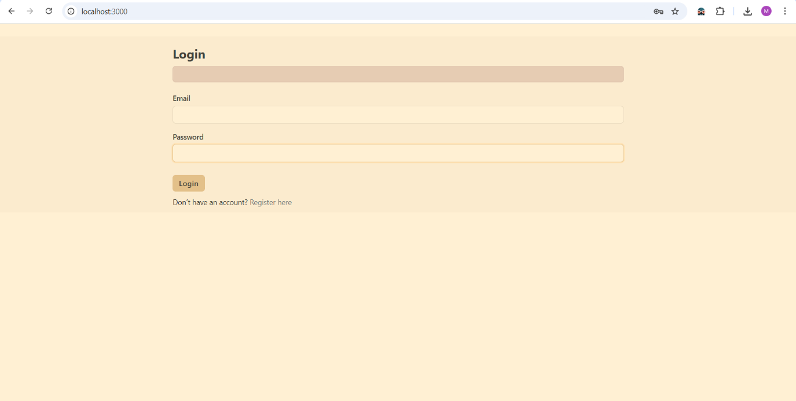
• Register Page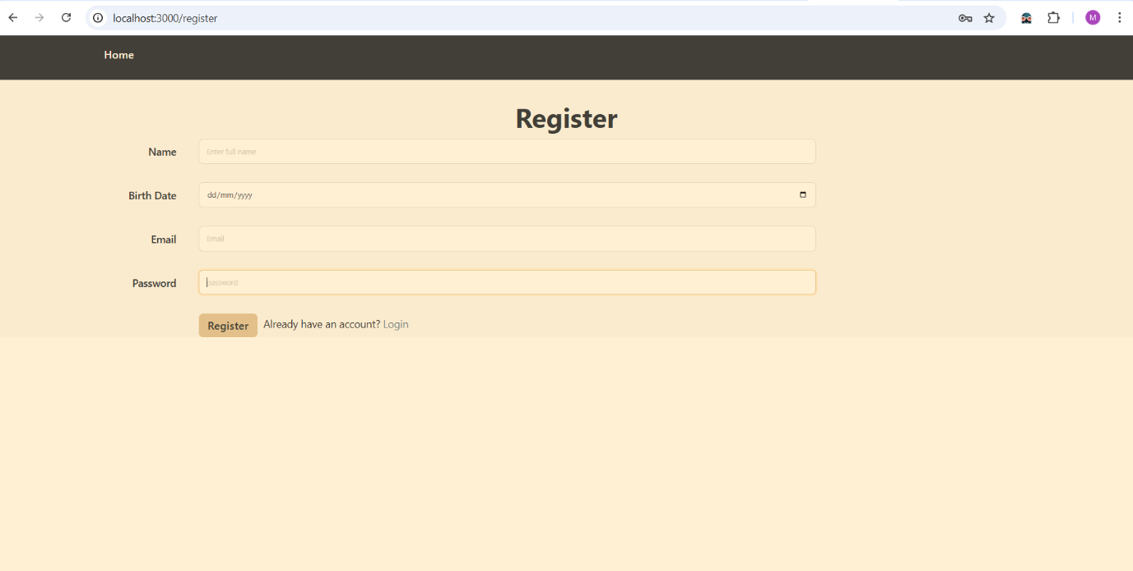
• Customer Dashboard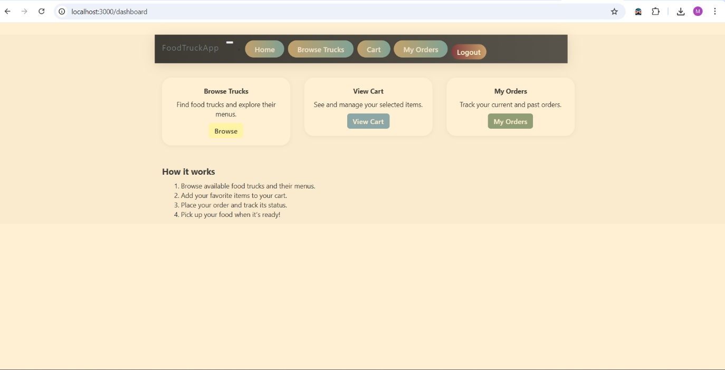
• Browse Trucks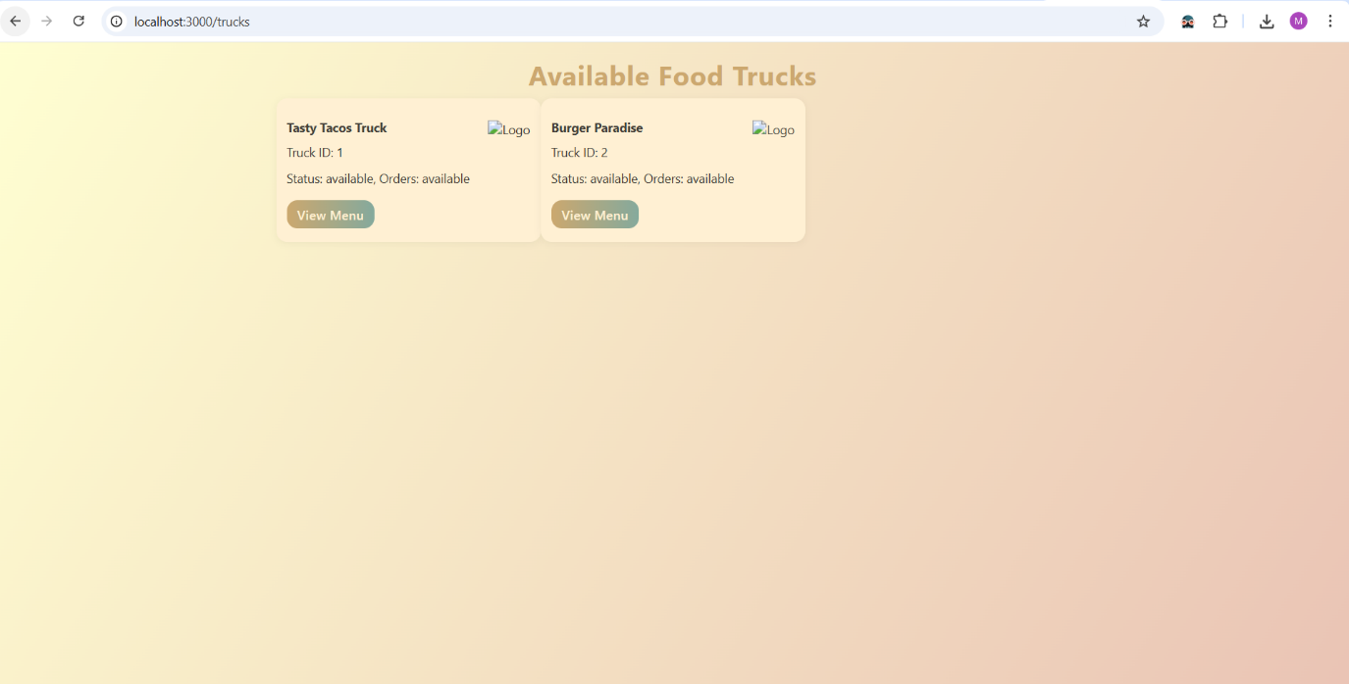
• Truck Menu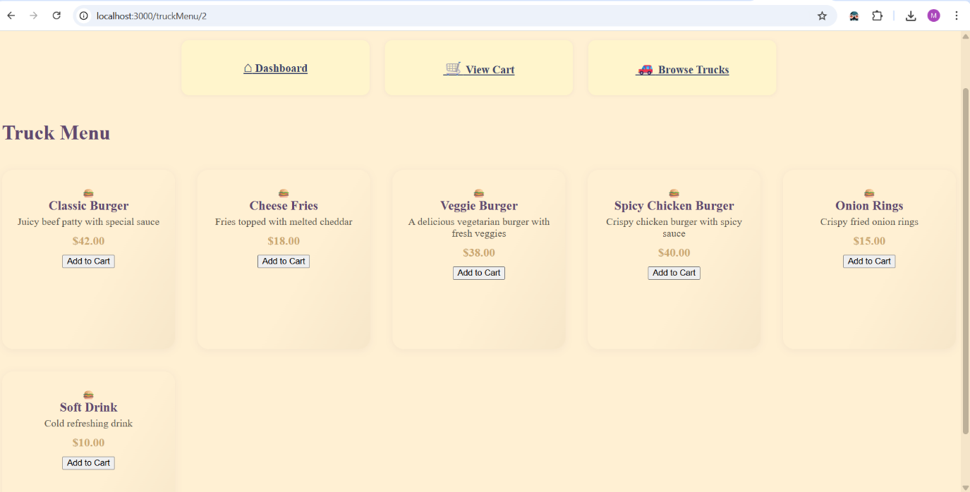
• Cart Page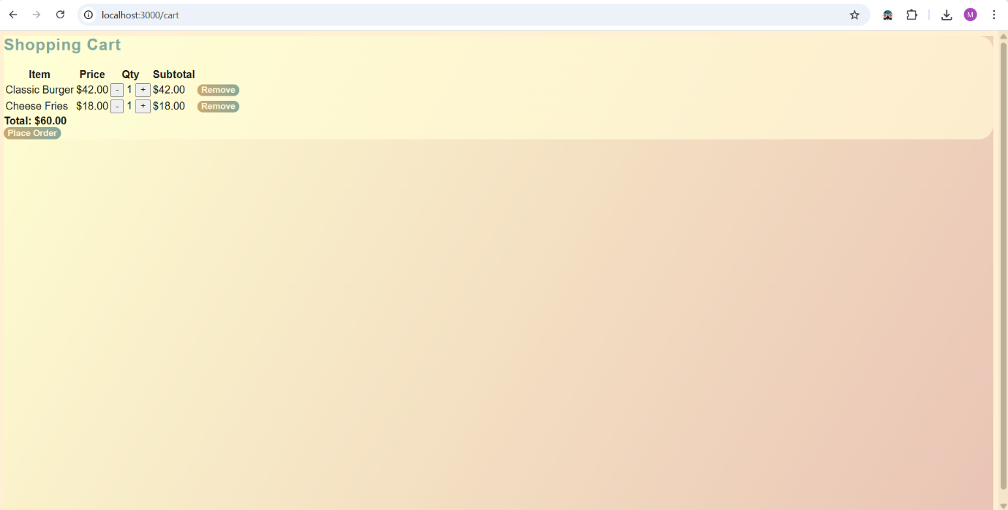
• My Orders Page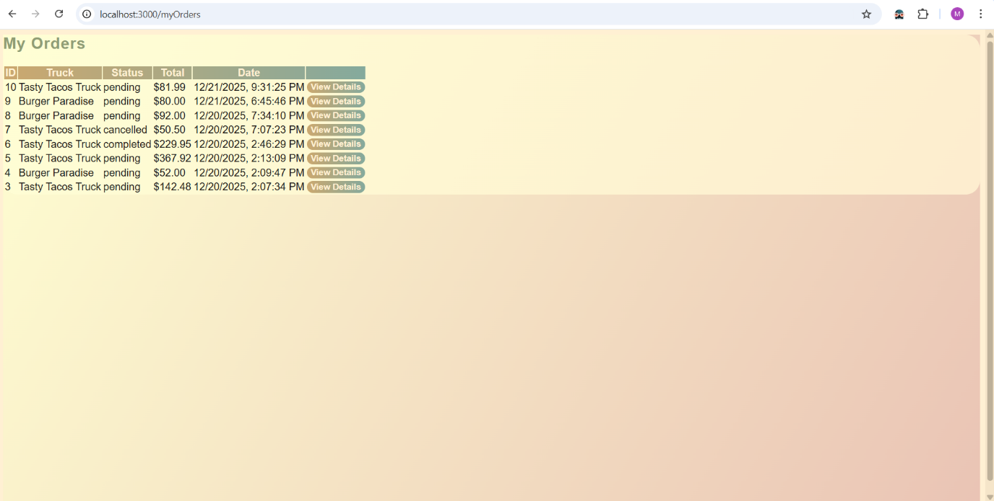
• Owner Dashboard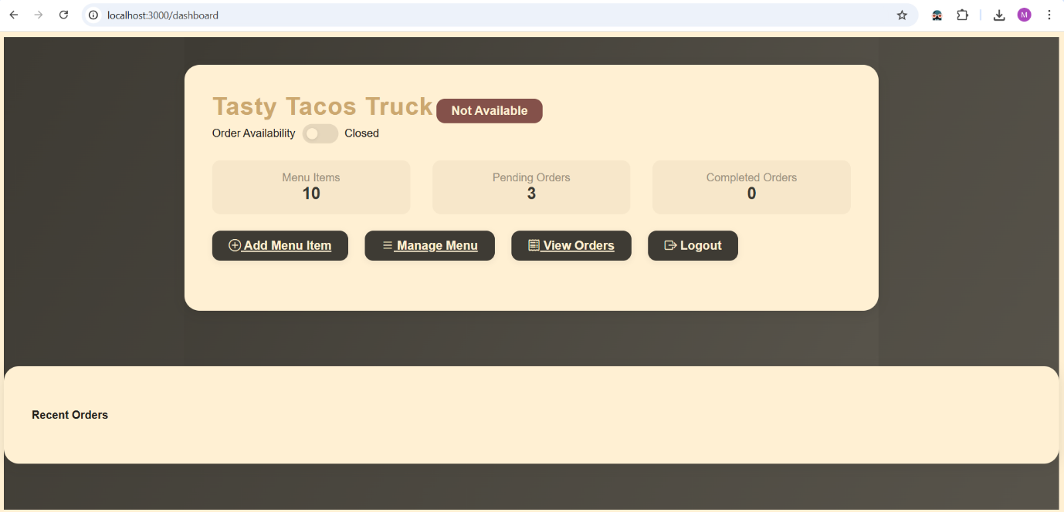
• Manage Menu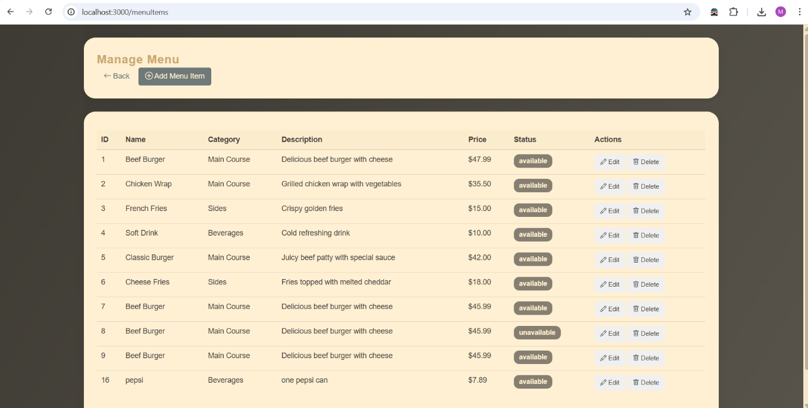
• Add Menu Item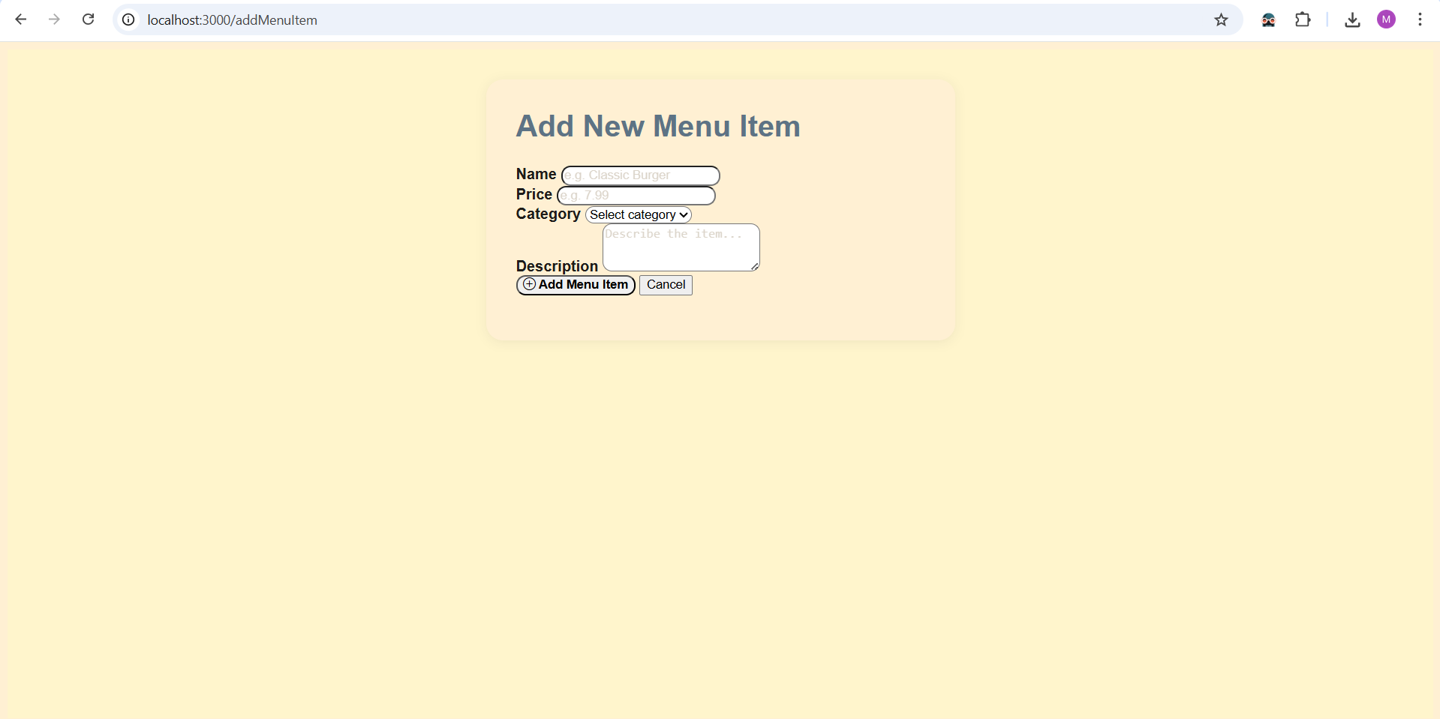
• View Orders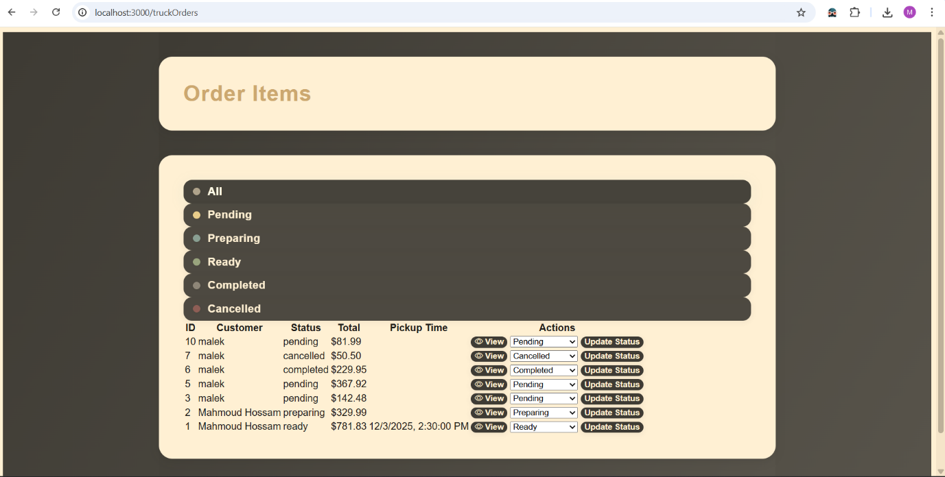

⸻

📡 API Endpoints Summary

🔓 Public APIs

Method Endpoint Description
POST /api/v1/user Register user
POST /api/v1/user/login User login

⸻

🔐 Protected APIs

Method Endpoint Description
GET /api/v1/trucks/view View all trucks
GET /api/v1/menu/:truckId Get truck menu
POST /api/v1/cart/add Add item to cart
GET /api/v1/cart View cart
POST /api/v1/order Place order
GET /api/v1/orders Customer orders
GET /api/v1/owner/orders Owner orders
POST /api/v1/order/update Update order status
POST /api/v1/menu/add Add menu item
POST /api/v1/menu/edit Edit menu item
POST /api/v1/menu/delete Delete menu item

⸻

👨‍💻 Contributor

Mahmoud Hossam Eldin Ibrahim
• Designed database schema
• Implemented backend APIs
• Developed frontend views and scripts
• Implemented authentication & authorization
• Handled cart & order logic
• Designed UI and user experience
• Tested and debugged all features
• Prepared documentation and README

